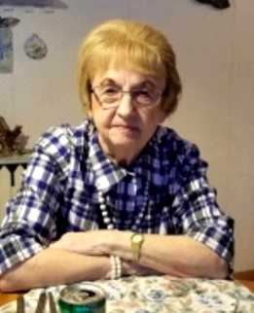

Dolores (Proft) Anderson
Thursday, February 26, 1931 – Thursday, December 12, 2024
93 years, 9 months, 16 days – (34,258 days)

Dolores (Proft) Anderson, 93, of Melrose, passed away at PineView Terrace in Black River Falls on December 12, 2024.
She was born February 26, 1931, in Merrill, Wis., to Vance and Palma Mitchell. Dolores was the youngest of 10 children. She graduated from Merrill High School.

On April 5, 1952, she married Jerry M. Proft. Together they lived by Tomahawk a short while until moving to Melrose in 1958. They had four children, Mike, Debbie, Pete, and John. Jerry passed away on May 13, 1983.

Dolores married David Anderson on May 26, 1991 and they enjoyed 20 years together until he passed away on June 10, 2011.

Following David’s passing, Dolores spent 11 years with her special and loving friend, Orea Erickson.

Dolores was very talented. She was an artist, poet, crafter, and her home was always decorated. She also loved baking, enjoying her flower gardens, going bowling, playing cards, and especially watching her kids play ball.

Dolores was a very active member of the Melrose United Methodist Church. She enjoyed the United Methodist Women’s meetings and helping decorate the church for the holidays.

Survivors include her son, Michael (Paula) Proft of Black River Falls; daughter, Debbie (Tim) Kreibich of Mindoro; daughter-in-law, Kris Proft of Black River Falls; seven grandchildren; 16 great-grandchildren; six great-great-grandchildren; and special friend and partner, Orea Erickson.

She was preceded in death by her parents; nine siblings and their spouses; first husband, Jerry Proft; second husband, David Anderson; and her beloved sons, Pete and John Proft.

A funeral service will be held at 11:00 a.m., on Wednesday, December 18, 2024, at the Melrose United Methodist Church. Burial will follow in the Melrose Cemetery. A visitation will be held from 9:00 a.m. until the time of service, Wednesday, at the church.

The family would like to give a heartfelt thanks to Dr. Rogers and the staff at PineView Terrace for your kindness and attentiveness to our mom. Also, thank you to St. Croix Hospice for all of your help and care.

